EXECUTIVE SUMMARY
Rongrenggre–Simsanggre–Nengkhra (RSN) Road (L=22.00 Km) do·a improvement ar widening ka·se, weak bridges pora permanent RCC bridges do·a conversion ka·se, Meghalaya Logistics and Connectivity Improvement Project (MLCIP) corridor do·a, World Bank fund ka·se.
Meghalaya Logistics and Connectivity Improvement Project (MLCIP)

Submitted
to

Meghalaya Infrastructure Development Finance Corporation (MIDFC) Ltd.
House No. L/A-56, Lower Nongrim Hills,Top Floor,
Meghalaya Basin Development Authority (MBDA) Building,
Shillong East Khasi Hills, Meghalaya-793003

ESIA Somaning (Summary)

Project Rang·chanchapa (Project Introduction)
Meghalaya Logistics and Connectivity Improvement Project (MLCIP) an·chingni miksongrangko dakchakanina kam ka·a, chong·motgipa nangchongmot ong·a:
a) chin·apgipa road corridor-rangni jakkalna dal·gipa bikrang aro growth center-rangona connection-ko namatna; b) grong-level aro district-level logistics infrastructure aro seva-rangko namatna;
c) select agriculture aro horticulture product-rangna marketona reach ong·e jakkalna, cost aro samai-ko komiatna; aro d) East Meghalaya-o climate-resilient transport aro logistics-ko chusok ong·e chalna institution-rangni capacity-ko bilangna.
Proposed road koba Meghalaya State bon∙kamani dongenga aro ROW ching∙a existing Drain chimong ong∙a. Proposed RSN project road a∙sel 22 km nokgipa, Rongrengre ato chainage 00+000 ong∙a aro Nengkra Bazar ato chainage 22+000 rango ja∙mano man∙gen, a∙selsalo project road miksongan ong∙a.
Niyam aro kanun-rang baksa meligrik ong·ani bynta
ESIA-ara ia niyam aro kanun-rang baksa meligrik ong·a:
- World Bank Environmental aro Social Framework (ESF)
- Environmental aro Social Standards (ESS 1–10)
- India Government aro Meghalaya Government-rang environmental niyam
- Labour, forest, biodiversity aro pollution control-rang kanun

Project-rang kam-chalna samai-suchi
Nang·ni set criteria aro conditions-rang baksa, MPWD civil works contract-ko eligible contractor-na debak ong·a. Contractor-na quality materials-ko pora jakkalna, nearest authorized source aro approved manufacturer-na laga debak ong·a. Construction process-rangni somai, prescribed standard-rang meet gipa equipment-ara use debak ong·a. Contractor-na construction schedule-rang baksa required manpower-ko mobilize debak ong·a. 22 km project road-rang construction period 24 month-rang baksa plan gipa ong·a.

Chong·ni pora environment-rang sthiti
Road corridor-rang soil sandy loam ong·a, well-drained aro moderately acidic ong·a, arangni region-rang high rainfall conditions-ina typical ong·a.
Water quality mostly fresh aro unpolluted ong·a, neutral pH-rang, sufficient dissolved oxygen-rang, low turbidity (monsoon-rang chadengsa except), aro low BOD/COD values ong·a. Industrial discharge nai, aro large-scale agricultural runoff-na water body-rang affect nai ong·a. Overall, water quality domestic use-ko baksa suitable ong·a, basic treatment-na pora use debak ong·a.
Ambient noise environment mostly quiet to moderately noisy ong·a, rural area-rang characteristics-ina baksa. Baseline noise level-rang CPCB limit-rang residential aro rural area-rang somai, day aro night, most location-ona meligrik ong·a.
Project corridor-rang air quality good to moderate ong·a, rural Meghalaya-rang characteristic-ina, industrial activity kom ong·a. Ambient concentration PM₁₀, PM₂.₅, SO₂, NO₂, aro CO generally National Ambient Air Quality Standards (NAAQS)-na meligrik ong·a.
Environment aro community-rang upor project-rang potential effect
Proposed road koridoro Environment Screeningo jakkalaniko matchotani baksa miksongani gimin chadengachi dongenga. Isolo dongachim monolith ato chainages 00+000 aro 22+000, religious aro cultural sako church - (2+200 RHS, 02+294 LHS), aro sa∙gni chol educational institution (Ch 02+220 LHS, 4+800 LHS, 11+076 LHS, 11+700 RHS).
Adverse impact-rang komiatna aro project implementation smooth ong·a baksa, appropriate mitigation measures propose gipa ong·a. Ni observation aro recommendation-rang summary table-ona dekha gipa ong·a.

Table: Observation-rang aro Corresponding Recommendation-rang
Chainage | EIS Observation (Garo Translation) | Proposed / Mitigation Measure Adopted (Garo Translation)
0+000 | Chisongni junctionrangni skanggrik dakna nikna ong∙a. | Junctionrangni nokgipa kamrangna improvement dakna gita.
0+000 – 6+200 | Reserve forest area ong∙a. | Forest area ong∙a jokatani ja∙mano, ronggitchamni jalaniko rim∙ani an∙chingni existing road.
6+300 | Junctionrangni skanggrik dakna nikna ong∙a. | Junctionrangni kamkota jokatani, speed restriction dakna gita.
6+350 | Building structure ong∙a RHS (Right Hand Side). | RHS-buildingrangni protectionna alignmentko chagiparang LHS-china shift dakna gita.
6+450 | Culvert ong∙a, impact ong∙ja. | –
6+900 | Minor bridge area-o soil erosion dakna ong∙a. | Soil erosion jokatani protection kam gita ong∙gen.
7+100 | Building structure RHS rangni ong∙a. | RHS buildingrangko protection dakna alignment LHS-china shift dakna gita.
7+280 | Bus stand dakna ong∙a. | Bus standrangni kamkota traffic island aro safety sign rakna gita.
8+000 | Junctionrangni skanggrik dakna ong∙a. | Junctionni poor geometry jokatani traffic island aro safety sign dakna gita. Junction improvement proposal gita.
11+400 | Culvert ong∙a, half-ni new, half-ni old, impact ong∙ja. | –
11+700 | Building structure RHS aro boundary wall impact dakna ong∙a. | - RHS buildingrangko alignment LHS-china shift dakna gita.  - Speed limit measure dakna gita.
11+900 | Landslide ranking RHS-o dakna ong∙a. | Landslide treatment plan dakna gita.
12+020 | School dakna ong∙a. | Retaining wall LHS-o dongonina km 12+020 – 12+040 rangni gita ong∙gen.
12+850 – 12+900 | Landslide RHS-o dakna ong∙a. | Landslide treatment plan dakna gita.
12+900 – 12+980 | Landslide LHS-o dakna ong∙a. | Landslide treatment plan dakna gita.
16+500 – 16+600 | Landslide LHS-ni dakna ong∙a. | Landslide treatment plan dakna gita.
17+300 – 17+340 | Pavement ronggitcham, water logging dakna ong∙a. | RHS protection work dakna aro road profileko chanchiani uamang gen.
20+637 (Projectni aroani) | Temporary houseni settlement connecting roadni cheani ong∙a. | –

Community aro social-rang pora dekha gipa observation-rang

Social screening-rang finding-rang table-ona dekha gipa ong·a:

Social screening-rang dekha gipa observation aro result-rang
S. No. | LHS/RHS | Chainage aro Distance | Center Line-ni Gimal | Impact-ni Type (Dake Nanganiko)
1 | RHS | 13+820 | 4.5 m | Residential structure-ni Bamboo fencing
2 | RHS | 16+200 | 4.5 m | Residential structure aro private field-ni Tin fencing
3 | RHS | 11+400 | 4.5 m | Residential structure-ni Tin fencing
4 | RHS | 11+700 | 5.0 m | Residential structure-ni Bamboo fencing
5 | RHS | 9+950 | 5.1 m | Pucca boundary wall aro pucca shop (ong∙gijan)
6 | RHS | 8+000 | 4.5 m | Residential structure-ni Tin fencing
7 | RHS | 20+300 | 5.2 m | Residential structure-ni Bamboo fencing aro temporary shop
8 | RHS | 10+000 | 5.3 m | Shop-o minor impact ong∙na man∙gen, maidake ownergipa-ni detail mandeja.
9 | RHS | 9+700 | 5.0 m | Residential structure-ni Tin fencing aro temporary shop
10 | RHS | 10+030 | 5.0 m | Residential structure-ni Bamboo fencing, private land, aro vegetation (gital gitchamrang)
11 | RHS | 20+470 | 5.4 m | Temporary shop aro land
12 | LHS | 20+480 | 5.4 m | Temporary shop aro land
Rongrenggre-Simsanggre-Nengkhra (RSN) Gono FPIC-3-ni Community Representative-rangni Katha aro Suggestionrangna Komplaiansani Jajong
Rongrenggre-Simsanggre-Nengkhra (RSN) Gono FPIC-3-ni Community Suggestionrang
Salni: 10-10-2025
Ja∙mano: Nengkra Rural Haat, Nengkra Bazar (NABARD-funding-o)
Chainage | Proposed / Mitigation Measure (Proposal / Katchani Kam) | Compliance / Proposal in DPR (DPR-o Dakboani / Proposalo)
20+637 (Project End) | Landslide zone-ni gimin road-ni pilak boko 2 toilet aro retaining wall namnika. | - Km 20+420 ato Km 20+430 rango retaining wall nangrimani ong∙a.  - 2 No. Toilet nangrimani ong∙a.
18+637 | Natural spring-ona jrimangako store ka∙na Spring Chamber namnika. | - CH 18+600 (LHS) ja∙mano Spring Chamber nangrimani ong∙a.

GRM-rang process aro steps-rang diagrammatic representation
Nangni flowchart-rang show gipa ong·a two-tier grievance redressal mechanism, responsibilities aro resolution-rang timelines-rang baksa debak.
Project site-ona grievance redressal-rang baksa debak level | Responsibility: VECs & Headman  Timeline: Resolution within 15 days  If unresolved → Escalate to PMU (Tier II)
State level-ona, PMU-rang grievance redressal-rang baksa debak level | Responsibility: Secretary Planning, Chief Engineer,  Project Director, Social Expert  Timeline: Resolution within 15 days

Grievance Redressal Mechanism-rang process, responsibilities aro resolution-rang steps-rang baksa debak.
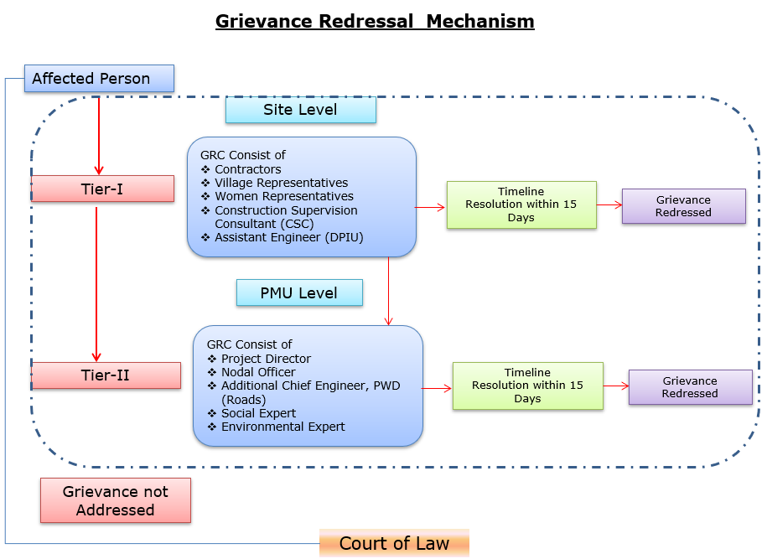
Grievances submit debak baksa contact information-rang baksa debak.
Baksa debak pora detail nai explanation | Baksa debak pora contact information, phone number, email, nai address
Company: | PWD, Meghalaya
To: | Chief Engineer-cum-Nodal officer
Address: | HV9P+GFJ, Lachumiere, Shillong, Meghalaya 793001
E-mail: | esmlcip@gmail.com
Website: | http://megpwd.gov.in/contacts.html
Telephone: | Tel: 0364-3572466
Fax: | -

Project-rang governance aro overall institutional structure-rang baksa debak.
Ka kam-rangkam ka dakgipa donggipa jylla Government of Meghalaya (GoM)-ni donggipa institutional architecture baksa meligrikgen, aro Sixth Schedule-ni niyam rangsani, janggi jatni hokrang (tribal autonomy)-ko dakchakgen.
MIDFC, je project-ni sabsi kamrangko dakchakgipa aro taka-paisani bynta nanggipa ong∙a, ua project-ni holder aro lead implementing agency ong∙gen.
MPWD-de civil works (rasta, bridge aro ropeway)-rangko dakchakgen, aro Department of Agriculture (DoA) aro MBMA-rangde agrologistics aro community components-rangko kam ka∙gen.
MIDFC-PMU-ni rangko project management aro coordination-rangko dakchakgen, World Bank-ni procedure-ko experience napha officers-ni through.
PMC, je team-ni expert aro consultant-rangni Team Leader-ni ong∙a dakchakgen, project activities-rangko technical support-ka∙gen, je implementing agencies-ni skill set-ni napha dang∙a.
CSC-ni construction supervision-ka∙gen.
PMC/CSC aro information collect aro document-ka∙gen-rangni aid ka∙gen.
Project implementation structure-ko figure-ni dang∙a dakchak:
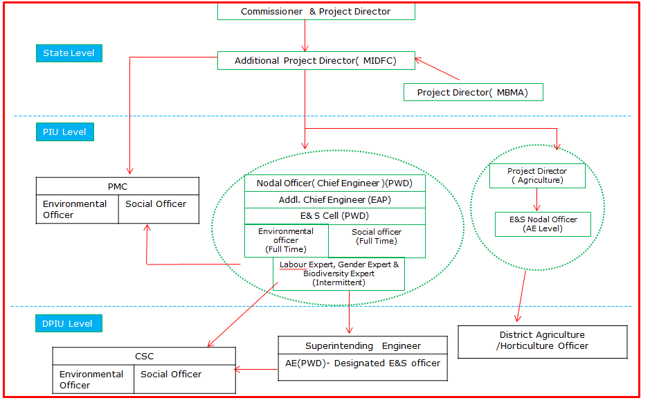
Figure: Project Kam-rangkam Organogram
Khutcha
ESIA-ni phayrang dakchakni phangni ni nangni gital:
- Proposed project-ni rasta-ni traffic flow-ni dakchakni aro motor vehicle aro pedestrian-ni safe aro smooth mobility-ka∙gen. Proposed road improvement-ni travel time-ni farthest section-ni rasta-ni dang∙a market-ni gi hour-ni 1 hako 30 minutes-ni mel∙a dakchak. Project-ni importance-ni trade aro commercial activity (public transport-ko include) East Garo Hills aro North Garo Hills-ni district-ni encouragement-ka∙gen.
- Environmental aro social impact assessment-ni World Bank ESF aro National & State regulations-ni meligrikgen. Pre-construction, construction aro operation phases-ni dang∙a potential impacts-ni dakchakni gital.
- Ronggitchamni road State Highway ong∙a, aro districtni elevation 150 m (low-lying eastern area-rango) ato 1,400 m (southwestern highland-rango) jakkalrangaha. 14th July 2022-ni EIA Notification an∙chingko miksonga je, Line of Control ka∙dongan international border-ni 100 km range defense ka∙dongan strategic importance-ni highway projectrang prior environmental clearance ong∙ja, uko Standard Operating Procedure (SOP) an∙tangtangni jakrango comply ka∙gimin. Ia an∙tango, proposed projecto environmental clearance namgija.
- Proposed project alignment Wildlife Sanctuary/National Park/Biosphere Reserve/Tiger Reserve-rango parik ja∙mano.
- Project site-ni 0.5 km-ni dang∙a ASI Protected monuments-ni dakchak∙a.
- Approximately 25 trees existing Right of Way (RoW)-ni dang∙a road-ni sides-ni dakchakni. Tree felling-ni ecological impact-ka∙gen mitigation-ni, compensatory afforestation-ni applicable environmental regulations aro guidelines-ni meligrikgen dakchak∙a.
- Project roado corridor range construction kamko man∙gipa, cultural importance sako community center, church, school, jemangan, aro Project-Affected Persons (PAPs)-na access-related issues ong∙gimin gita jak environmental aro social impact ong∙na man∙gen.
- Stakeholder Consultations manderangni proposed project gimin kattarangko assess ka∙na dakaha. Consultations-ni outcome manderang projectko dakaha maina ia ronggitchamni road condition aro connectivityko improve ka∙gen. Indiba, uamang road safety measures; road furniture (streetlights, signage, speed breaker, jemangan) aro uamangni assets rong∙anina proper compensation-ni kattarangko daka.
- Worker aro local community-ni occupational health aro safety measures Labour Management Plan (LMP) preparation aro implementation ka∙anina World Bank-ni Environmental and Social Standard ESS2 (Labour aro Working Conditions) an∙tangtangna comply ka∙na gita man∙gen.
- Ia mitigationsko construction aro operation ja∙mano environmental aro social monitoring program dakna gita katchakaha je, pilak measures implementation ong∙a aro environmental aro social condition an∙tangtangna stipulate ka∙a protect ka∙a. Ia on-site aro off-site observation, document check, worker aro beneficiary-rangna interview, aro remedial action namgipa kattarang contractor MPWD-na report ka∙a.
- ESMP bidding document-o contractual clause an∙tangtang-ba safeguard ka∙anina environment aro social impact project construction aro operation (maintenance period) ja∙mano ong∙gimin. ESMP bidding document-o dakboaha.
- Overall project level aro construction stage level Grievance Redress Mechanism (GRM) affect gipa partyrangna feedback, suggestion aro complaint, jemangan, receive ka∙na aro construction stage aro operation stage ja∙mano address ka∙na ong∙gen.
- Prepared ESMP Contractor aro MPWD-na Environmental aro Social impacts katchakna aro proposed project environmentally sound execution ka∙na guide ka∙gen.
- Updated ESMP-ni kopi construction period ja∙mano on-site chakatako ra∙na gita. World Bank policy requirement an∙tangtangni jakrango, prepared safeguard documents World Bank website-o disclose ong∙gen.

Capacity building and training

Environmental aro Social Management Plan (ESMP)-ni implementation aro monitoring-ni capability-ni improve-ka∙gen, structured training programs-ni contractor aro project personnel-ni gi sabsi conduct-ka∙gen dakchakni recommend-ka∙gen.

Training-ni regulatory requirements-ni compliance ensure-ka∙gen, awareness improve-ka∙gen aro environmental aro social (E&S) risks-ni manage-ka∙gen competence build-ka∙gen.

On-Boarding Phase
a. Induction Training
•Sabsi personnel-ni work start-ka∙gen ni mandatory.
• Contractor-ni Environmental aro Social Management Plan (C-ESMP), relevant national aro international Environmental, Social, Health aro Safety (ESHS) regulations aro good practices-ni cover-ka∙gen.
b. Specialized Training

•Personnel-ni specific roles-ni (e.g., environmental officer, safety officer, waste management supervisor) assigned-ka∙gen tailored training.
• Mobilization stage-ni deliver-ka∙gen, assigned responsibilities-ni readiness ensure-ka∙gen.

Implementation Phase
- Ongoing Toolbox Talks:
Daily aro weekly conduct-ka∙gen, evolving risks address-ka∙gen, safety practices reinforce-ka∙gen aro workers-ni continuous awareness maintain-ka∙gen.
- Supplemental Training:
Incident-hako pare or new risks identify-hako pare provide-ka∙gen. Recurrence prevent-ka∙gen aro workforce-ni new safety/environmental requirements-ni updated rakha∙gen.
- Routine Quarterly Training:
- Contractor-ni every three months organize-ka∙gen:
- E&S compliance status aro progress review-ka∙gen.
- Previous quarter-ni lessons learned share-ka∙gen.
- Identified gaps aro challenges address-ka∙gen action plans develop-ka∙gen.
- Sub-project E&S objectives-ni alignment ensure-ka∙gen aro continuous improvement promote-ka∙gen.

Outcomes of the stakeholders

Rongrenggre-Simsanggre-Nengkhra Road-ni FPIC process community engagementko gima strong ka∙a aro final consent ong∙aha.

FPIC-I-o, community-ni kattarang road widening-ni gimin land requirement, livelihood impact, aro safety gita ong∙aha. Project team impact minimal ong∙gen aro a∙selgipin existing right of way-o ong∙gen ine chakchikaaha, jekon applicable ong∙a uko compensation man∙gen ine assure ka∙aha, aro design measures aro Grievance Redressal Mechanism implementation ja∙mano kattarangko address ka∙gen ine confirm ka∙aha.

FPIC-II meeting-o, manderang road widening, drainage problem, soil erosion, aro nok, farm, roadside property access-o disturbance gimin kattarang daka. Project team kam a∙selgipin existing ROW-o ong∙gen ine, proper drain, culvert, retaining wall man∙gen ine, manderangko advance-o agana ine, aro site inspection aro Grievance Redressal Mechanismo kattarangko address ka∙gen ine assure ka∙aha.

FPIC-III meeting-o, Stakeholderrang drainage, landslide safety, basic amenities, water source protection, aro local vendorrangna impact gimin kattarang daka. Project team survey ongoing ong∙a ine, amenities DPR-o include ong∙a ine, water source protectionko examine ka∙gen ine, aro affect gipa vendorang compensation assess ka∙gen ine assure ka∙aha.

FPIC-IV meeting-o, stakeholderrang projectko overall support ka∙aha aro new kattarang dongja. Project team drainage, retaining wall, public toilet, parking space, jemangan earlier kattarang DPR-o address aro include ong∙a ine confirm ka∙aha. Environmental aro social impact World Bank requirement an∙tangtangna manage ong∙gen ine assure ka∙aha, aro road improvement-na written consent community-ona man∙aha.

Resettlement Action Plan (RAP)

Resettlement Policy Framework (RPF)-ni gi meligrik, project-ni social impacts avoid aro minimize-ka∙gen measures adopt-ka∙gen, careful design aro existing RoW-ni use-ka∙gen.
Continuous consultations conduct-ka∙gen aro functional GRM-ni ensure-ka∙gen, concerns-ni timely resolve-ka∙gen. Sabsi entitlements RPF-ni meligrik provide-ka∙gen.
Road section-ni identified impacts-ko basis-ni, detailed site-specific Resettlement Action Plan (RAP) prepare-ka∙gen, ha·ni final entitlements, mitigation measures, implementation arrangements aro monitoring framework outline-ka∙gen, aro civil works start-hako pare implement-ka∙gen.

